ESimSol Accounting System

Concept document

**What is accounting?**

ESimsol **accounting system** is a tool of [accountancy](http://en.wikipedia.org/wiki/Accountancy) , which is the measurement, disclosure or provision of assurance about financial information that helps managers, investors, tax authorities and others make decisions about allocating resources. The key concepts of accountancy are as follows:

1. Bookkeeping- is the recording of financial transactions. Transactions include sales, purchases, income, receipts and payments by an individual or organization
2. Accounting period-in [bookkeeping](http://en.wikipedia.org/wiki/Bookkeeping) is the period with reference to which accounting books of any entity are prepared. There must be an accounting year in Accounting system like January 2012 to December 2012.
3. Income Statement
4. Owner’s equity statement
5. Balance Sheet
6. Statement of Cash flow
7. Accrual
8. Cash flow forecasting
9. Charts of accounts
10. Journal - Transactions first recorded **using Debits and Credits**
11. Special journal
12. Constraint item Purchasing power accounting
13. Cost of goods sold -refer to the [inventory](http://en.wikipedia.org/wiki/Inventory) costs of those goods a business has sold during a particular period.
14. Credit terms
15. Debit & credits
16. Double entry system
17. General Ledger- Summarized transactions posted to the General Ledger Accounts **using Debits and Credits**
18. Historical cost-
19. Matching principals
20. Revenue recognition
21. Trail Balance

The basic Concept of Accenting:

Accounting Basic Equation:

Assets = Liabilities + Owner’s Equity

Assets   
**Formal Definition:**   
The properties used in the operation or investment activities of a business.

**Informal Definition**:  
 All the good stuff a business has (anything with value). The goodies.

**Additional Explanation:**   
The good stuff includes tangible and intangible stuff. Tangible stuff you can physical sees and touches such as vehicles, equipment and buildings. **Intangible stuff is like pieces of paper (sales invoices) representing loans to your customers where they promise to pay you later for your services or product**. Examples of assets that many individuals have are cars, houses, boats, furniture, TV's, and appliances. Some examples of business type assets are

1. cash,
2. accounts receivable,
3. notes receivable,
4. inventory,
5. Land and equipment.

Liabilities   
**Formal Definition:**Claims by creditors to the property (assets) of a business until they are paid.

**Informal Definition:**  
Other's claims to the business's good stuff. Amounts the business owes to others.

**Additional Explanation:**  
Usually one of a business's biggest liabilities (hopefully they are not past due) is to suppliers where a business has bought goods and services and charged them. This is similar to us going out and buying a TV and charging it on our credit card. Our credit card bill is a liability. Another good personal example is a home mortgage. Very few people actually own their own home. The bank has a claim against the home which is called a mortgage. This mortgage is another example of a personal liability. Some examples of business liabilities are

1. accounts payable,
2. notes payable,
3. Mortgages payable.
4. Bank loan

Owner's Equity also called Owner's Capital   
**Comment:**Both terms may be used interchangeably. In my tutorial lessons, I may refer to both terms or just use one or the other.

**Formal Definition:**   
The owner's rights to the property (assets) of the business; also called proprietorship and net worth.

**Informal Definition:**  
What the business owes the owner. The good stuff left for the owner assuming all liabilities (amounts owed) have been paid.

**Additional Explanation:**   
Owner's Equity (Capital) represents the owner's claim to the good stuff (assets). Most people are familiar with the term equity because it is so often used with lenders wanting to loan individuals money based on their home equity. Home equity can be thought of as the amount of money an owner would receive if he/she sold their house and paid off any mortgage (loan) on the property.

Revenue (Income), Expenses, Investment, and Draws   
Revenues, expenses, investment, and draws are sub categories of owner's equity (capital). Think of owner's equity as a mom named Capital with four children to keep up with (I know she's only got one clinging to her leg but she left Expense, Investment, and Draws at home). The kids are named Revenue, Expense, Investment, and Draws and each kid has one job that they are responsible for in order to earn their allowance. **Kid Revenue** is responsible for keeping track of increases in owner's equity (Ma Capital) and **Kid Expense** is responsible for keeping track of decreases in owner's equity (Ma Capital) resulting from business operations. **Kid Draws** has the job of keeping up with decreases in owner's equity (Ma Capital) resulting from owner withdrawals for living expenses and other personal expenses. **Kid Investment** has the job of keeping up with increases in owner's equity (Ma Capital) resulting from additional amounts invested in the business.

Revenue also called Income   
**Formal Definition:**   
The gross increase in owner's equity (capital) resulting from the operations and other activities of the business.

**Informal Definition:**   
Amounts a business earns by selling services and products. Amounts billed to customers for services and/or products.

**Additional Explanation:**Individuals can best relate by thinking of revenue as their earnings/wages they receive from their job. Most business revenue results from selling their products and/or services.

Expense also called Cost   
**Formal Definition:**  
Decrease in owner's equity (capital) resulting from the cost of goods, fixed assets, and services and supplies consumed in the operations of a business.

**Informal Definition:**The costs of doing business. The stuff we used and had to pay for or charge to run our business.

**Additional Explanation:**Some examples of personal expenses that most individuals are familiar with are utilities, phone, clothing, food, gasoline, and repairs. Some examples of business expenses are

1. office supplies,
2. salaries & wages,
3. advertising,
4. building rental,
5. And utilities.

Owner's Investments   
**Formal Definition:**   
Increase in owner's equity (capital) resulting from additional investments of cash and/or other property made by the owner.

**Informal definition:**   
Additional amounts, either cash or other property that the owner puts in his business.

**Additional Explanation:**   
Although these amounts can be kept up with as a separate item, they are usually recorded directly in the Owner's Capital Account. In other words, immediately put into Ma Equity's purse.

Owner's Drawing   
**Formal Definition:**   
Decrease in owner's equity (capital) resulting from withdrawals made by the owner.

**Informal definition:**   
Amounts the owner withdraws from his business for living and personal expenses.

**Additional Explanation:**   
The owner of a sole proprietorship does not normally receive a "formal" pay check from the business, but just like most of the rest of us needs money to pay for his house, car, utilities, and groceries. An owner's draw is used in order for the owner to receive money or other "goodies" from his business to take care of his personal bills.

# Definitions of Debits and Credits

## Debit

• An entry in the financial books of a firm that increases an asset or an expense or an entry that decreases a liability, owner's equity (capital) or income.

• Also, an entry entered on the left side (column) of a journal or general ledger account.

• Let's combine the two above definitions into one complete definition.   
An entry (amount) entered on the left side (column) of a journal or general ledger account that increases an asset, draw or an expense or an entry that decreases a liability, owner's equity (capital) or revenue.

## Credit

• An entry in the financial books of a firm that increases a liability, owner's equity (capital) or revenue, or an entry that decreases an asset or an expense.

• Also, an entry entered on the right side (column) of a journal or general ledger account.

• Let's combine the two above definitions into one complete definition.   
An entry (amount) entered on the right side (column) of a journal or general ledger account that increases a liability, owner's equity (capital) or revenue, or an entry that decreases an asset, draw, or an expense.

The term debit refers to the left side of an account and credit refers to the right side of an account. A debit is always entered in the left hand column of a Journal or Ledger Account and a credit is always entered in the right hand column. Debit is abbreviated Dr. and Credit is abbreviated Cr.

When you post (record) an entry in the left hand column of an account you are debiting that account. Whether the debit is an increase or decrease depends on the type of account. Likewise, when you post (record) an entry in the right hand column of an account you are crediting that account. Whether the credit is an increase or decrease depends on the type of account.

## Our Simple Debit / Credit Rule:

* All Accounts that **Normally Have a Debit Balance** are **Increased with a Debit** by placing the amount in the **Left Column** of the account and **Decreased with a Credit** by placing the amount in the **Right Column** of the account.
  + **A**ssets
  + **D**raws
  + **E**xpenses
* All Accounts that **Normally have a Credit Balance** are **Increased with a Credit** by placing the amount in the **Right Column** of the account and **Decreased with a Debit** by placing the amount in the **Left Column** of the account.
  + **L**iabilities
  + **O**wner's Equity ( Capital )
  + **R**evenue

Additional Clarification:   
Since **A**ssets, **D**raw, and **E**xpense Accounts **normally have a Debit Balance**, in order to Increase the Balance of an **A**sset, **D**raw, or **E**xpense Account enter the amount in the Debit or Left Side Column and in order to Decrease the Balance enter the amount in the Credit or Right Side Column.

Likewise, since **L**iabilities, **O**wner's Equity (Capital), and **R**evenue Accounts **normally have a Credit Balance** in order to Increase the Balance of a **L**iability, **O**wner's Equity, or **R**evenue Account the amount would be entered in the Credit or Right Side Column and the amount would be entered in the Debit or Left Side column to Decrease the Account's Balance.

**The Debit and Credit Rules Presented as A Table**

|  |  |  |  |  |  |  |
| --- | --- | --- | --- | --- | --- | --- |
| Account Type | | | Normal Balance | Increase To Account Balance | Decrease To Account Balance | Account Example |
| Property Accounts | | | | | | |
| Asset | | | **Debit** | **Debit - Left Column** Of Account | **Credit - Right Column** Of Account | Cash, Accounts Receivable |
| Property Rights Accounts | | | | | | |
| Liability | | | **Credit** | **Credit - Right Column** Of Account | **Debit - Left Column** Of Account | Accounts Payable |
| Owner's Equity | | | **Credit** | **Credit - Right Column** Of Account | **Debit - Left Column** Of Account | Owner's Capital |
| Revenue | | | **Credit** | **Credit - Right Column** Of Account | **Debit - Left Column** Of Account | Sales |
| Costs and Expenses | | | **Debit** | **Debit - Left Column** Of Account | **Credit - Right Column** Of Account | Rent, Utilities, Advertising |
| Owner Draws | | | **Debit** | **Debit - Left Column** Of Account | **Credit - Right Column** Of Account | Owner Draws |
|  |

## Sale-Sell goods and/or services

* **(1)** Cash Sale-customer pays at the time of sale   
  The business **gets** cash or a check from their customer and **gives** up a product or service to their customer.   
  **Accounts Used:**   
  Debit: Cash      
  Credit: Sales
* **(2)** On Account Sale-business allows the customer time to pay   
  the business **gets** a promise to pay from their customer and **gives** up a product or service to their customer.   
  **Accounts Used:**   
  Debit: Accounts Receivable      
  Credit: Sales

[Note: When the business received cash against this sale after a time period, what will be the account effect?]

## Purchase goods and/or services

* **(3)** Cash Purchase-business pays the supplier at the time of purchase   
  the business **gets** a product or service from their supplier and **gives** up cash or a check to their supplier.   
  **Accounts Used:**   
  Debit: Expense or Inventory Account      
  Credit: Cash
* **(4)** On Account Purchase-supplier allows the business time to pay   
  The business **gets** a product or service from a supplier and **gives** up a promise to pay to their supplier.   
  **Accounts Used:**   
  Debit: Expense or Inventory Account      
  Credit: Accounts Payable

[Note: When the business paid cash against this sale after a time period, what will be the account effect?]

* **(5) Pay Supplier Charge Purchases** -pay suppliers for products and/or services that we promised to pay for later (charge).   
  The business **gets** the amount of their promise to pay the supplier reduced and **gives** up cash or a check.   
  **Accounts Used:**   
  Debit: Accounts Payable      
  Credit: Cash
* **(6) Receive Customer Charge Payments** -receive payments from a customer that promised to pay us later (charge sale).   
  The business **gets** cash or a check from their customer and **gives** up (reduces the amount of) their customer's promise to pay.   
  **Accounts Used:**   
  Debit: Cash      
  Credit: Accounts Receivable
* **(7) Borrow Money** (Loans) The business **gets** cash or equipment and **gives** up a promise to pay.   
  **Accounts Used:**   
  Debit: Cash or Equipment      
  Credit: Note Payable
* **(8) Repay a Loan**   
  The business **gets** the amount of their promise to pay reduced and **gives** up cash or a check.   
  **Accounts Used:**   
  Debit: Note Payable      
  Credit: Cash
* **(9) Draw**   
  The business **gets** the owner's claim to the business assets reduced and **gives** up cash or a check.  **Accounts Used:**   
  Debit: Owner's Draw      
  Credit: Cash
* **(10) Payroll** (not covered in this tutorial)   
  The business **gets** services from their employees and **gives** up a check.   
  **Accounts Used:**   
  Debit: Salary & Wages Expense      
  Credit: Cash

# Description of some Accounting key concept

## Charts of Account

The chart of accounts is a listing of all [accounts](http://www.accountingtools.com/definition-account) used in the [general ledger](http://www.accountingtools.com/definition-general-ledger), usually sorted in order by account number. The accounts are usually numeric, but can also be alphabetic or alphanumeric. It is used to organize the finances of the entity and to segregate expenditures, revenue, assets and liabilities in order to give interested parties a better understanding of the financial health of the entity.

Within the chart of accounts, the accounts are typically listed in two orders:

1. Balance Sheet Account
2. Profit & Loss Account

### Balance sheet accounts

There are three accounts are listed in Balance sheet Account that is given below:

1. Asset Account
2. Liability Account
3. Stockholders’ Equity Account

#### Asset Account

There are two types of asset

1. Current Asset
2. Fixed Asset

##### Charts of Current Asset Account (Ac No 101-200)

|  |  |  |  |
| --- | --- | --- | --- |
| **AC NO** | **Account Title** | **To Increase** | **Description** |
| 101 | Cash - Regular Checking | Debit | Checking account balance (as shown in company records), currency, coins, checks received from customers but not yet deposited. |
| 102 | Cash - Payroll Checking | Debit |  |
| 103 | Petty Cash Fund | Debit | Balance in Cash drawer. |
| 104 | Accounts Receivable | Debit | Amounts owed to the company for services performed or products sold but not yet paid for. |
| 105 | Allowance for Doubtful Accounts | Debit |  |
| 106 | Inventory | Debit | Cost of purchased but has not yet been sold. |
| 106 | Supplies | Debit | Cost of supplies that have not yet been used. Supplies that have been used are recorded in Supplies Expense. |
| 107 | Prepaid Insurance | Debit | Cost of insurance that is paid in advance and includes a future accounting period. |
| 108 | Marketable Security | debit | A marketable security is an easily traded [investment](http://www.accountingtools.com/definition-investment), such as treasury bills, that is easily converted into [cash](http://www.accountingtools.com/definition-cash). It is recorded as a [current asset](http://www.accountingtools.com/definition-current-asset). |

##### Charts of Fixed Asset Account (201-299)

|  |  |  |  |
| --- | --- | --- | --- |
| **AC No** | **Account Title** | **To Increase** | **Description** |
| 201 | Land | Debit | Cost to acquire and prepare land for use by the company. |
| 202 | Buildings | Debit | Cost to purchase or construct buildings for use by the company. |
| 203 | Equipment | Debit | Cost to acquire and prepare equipment for use by the company. |
| 204 | Vehicles | Debit | Cost to vehicles for use by the company. |
| 205 | Accumulated Depreciation - Buildings | Credit | Amount of the buildings' cost that has been allocated to Depreciation Expense since the time the building was acquired. (Contra account) |
| 206 | Accumulated Depreciation - Equipment | Credit | Amount of equipment's cost that has been allocated to Depreciation Expense since the time the equipment was acquired. (Contra account) |
| 207 | Accumulated Depreciation - Vehicles | Credit | Amount of vehicle's cost that has been allocated to Depreciation Expense since the time the equipment was acquired. (Contra account) |

#### Liabilities Account

There are two types of Liabilities

1. Current Liabilities
2. Long Term Liabilities

##### Charts of Current Liabilities Account (Ac No 301-399)

|  |  |  |  |
| --- | --- | --- | --- |
| **Ac No** | **Account Title** | **To Increase** | **Description** |
| 301 | Notes Payable | Credit | The amount of [principal](http://www.accountingcoach.com/terms/P/principal.html) due on a formal written promise to pay. Loans from banks are included in this account. |
| 302 | Accounts Payable | Credit | Amount owed to suppliers who provided goods and services to the company but did not require immediate payment in cash. |
| 303 | Wages Payable | Credit | Amount owed to employees for hours worked but not yet paid. |
| 304 | Interest Payable | Credit | Amount owed for interest on Notes Payable up until the date of the balance sheet. This is computed by multiplying the amount of the note times the effective times the time period. |
| 305 | Unearned Revenues | Credit | Amounts received in advance of delivering goods or providing services. When the goods are delivered or services are provided, this liability amount decreases. |

##### Charts of Long Term Liabilities Account (Ac No 401-499)

|  |  |  |  |
| --- | --- | --- | --- |
| **Ac No** | **Account Title** | **To Increase** | **Description** |
| 401 | Mortgage Loan Payable | Credit | A formal loan that involves a lien on real estate until the loan is repaid. |
| 402 | Bonds Payable | Credit |  |
| 403 | Discount on Bonds Payable | Credit |  |

#### Stockholders’ Equity Account (Ac No 501-599)

|  |  |  |  |
| --- | --- | --- | --- |
| **Ac No** | **Account Title** | **To Increase** | **Description** |
| 501 | Common Stock (Share Capital) | Credit | Amount the owner invested in the company (through cash or other assets) plus earnings of the company not withdrawn by the owner. |
| 502 | Retained Earnings (Revenue Reserves) | Credit | When a corporation earns a [profit](http://en.wikipedia.org/wiki/Profit_(accounting)) or surplus, that money can be put to re-invested in the business. |
| 503 | Drawings | Debit | Amount that the owner of the sole proprietorship has withdrawn for personal use during the current accounting year. At the end of the year, the amount in this account will be transferred into Mary Smith, Capital (account 501). |

### Profit & Loss Account

There are three accounts are listed in Profit Loss Account that is given below:

1. Revenue Account
2. Cost of goods sold Account
3. Expense Account

#### Revenue Account (Ac No 601-699)

|  |  |  |  |
| --- | --- | --- | --- |
| **AC NO** | **Account Title** | **To Increase** | **Description** |
| 601 | Sales & Service Revenue | Credit |  |
| 602 | Sales Returns & Allowances |  |  |
| 603 | Sales Discounts |  |  |
| 604 | Interest Income |  |  |

#### Cost of goods sold Account (Ac No 801-899)

|  |  |  |  |
| --- | --- | --- | --- |
| **AC NO** | **Account Title** | **To Increase** | **Description** |
| 601 | Purchases expense | Credit |  |
| 602 | Sales Expense | Debit |  |
| 603 | Purchase Returns & Allowances | Credit |  |

#### Expense Account (Ac No 901-999)

|  |  |  |  |
| --- | --- | --- | --- |
| **AC NO** | **Account Title** | **To Increase** | **Description** |
| 901 | [Salaries Expense](http://www.accountingcoach.com/terms/S/salaries-expense.html) | Debit | Expenses incurred for the work performed by salaried employees during the accounting period. These employees normally receive a fixed amount on a weekly, monthly, or annual basis. |
| 902 | [Wages Expense](http://www.accountingcoach.com/terms/W/wages-expense.html) | Debit | Expenses incurred for the work performed by non-salaried employees during the accounting period. These employees receive an hourly rate of pay. |
| 903 | [Supplies Expense](http://www.accountingcoach.com/terms/S/supplies-expense.html) | Debit | Cost of supplies used up during the accounting period. |
| 904 | [Rent Expense](http://www.accountingcoach.com/terms/R/rent-expense.html) | Debit | Cost of occupying rented facilities during the accounting period. |
| 905 | Utilities Expense | Debit | Costs for electricity, heat, water, and sewer that were used during the accounting period. |
| 906 | [Telephone Expense](http://www.accountingcoach.com/terms/T/telephone-expense.html) | Debit | Cost of telephone used during the current accounting period. |
| 907 | [Advertising Expense](http://www.accountingcoach.com/terms/A/advertising-expense.html) | Debit | accounting period for ads, promotions, and other selling and expenses (other than salaries). |
| 908 | [Depreciation Expense](http://www.accountingcoach.com/terms/D/depreciation-expense.html) | Debit | Cost of long-term assets allocated to expense during the current accounting period. |

**Example:**

|  |  |  |
| --- | --- | --- |
| **Chart Of Accounts** | **Debit** | **Credit** |
|  | **£2,500.00** | **£2,500.00** |
| **Balance Sheet Items** |  | **£1,000** |
| Assets |  | £2,000.00 |
| Liabilities | £1,000.00 |  |
| **Profit and Loss Items** |  | **£1,500.00** |
| Income |  | £3,000.00 |
| Expenses | £1,500.00 |  |

## Journals

The general journal is where [double entry bookkeeping](http://en.wikipedia.org/wiki/Double-entry_bookkeeping_system) entries are recorded by [debiting](http://en.wikipedia.org/wiki/Debit) one or more accounts and crediting another one or more accounts with the same total amount. The total amount debited and the total amount credited should always be equal, thereby ensuring the [accounting equation](http://en.wikipedia.org/wiki/Accounting_equation) is maintained.

**Example: (Sales journal)**

|  |  |  |  |
| --- | --- | --- | --- |
| **SL** | **Particulars** | **Debit** | **Credit** |
| 1 | Cash in checking | $71.02 |  |
|  | Sales |  | $67.00 |
|  | Sales Tax Collected |  | $4.02 |

## Special Journals

Special Journals are designed to facilitate the process of journalizing and posting transactions. They are used for the most frequent [transactions](http://en.wikipedia.org/wiki/Financial_transaction) in a business. For example, in merchandising businesses, companies acquire merchandise from vendors, and then in turn sell the merchandise to individuals or other businesses. [Sales](http://en.wikipedia.org/wiki/Sales) and [purchases](http://en.wikipedia.org/wiki/Purchases) are the most common transactions for the merchandising businesses.

**Example (Sales journal)**

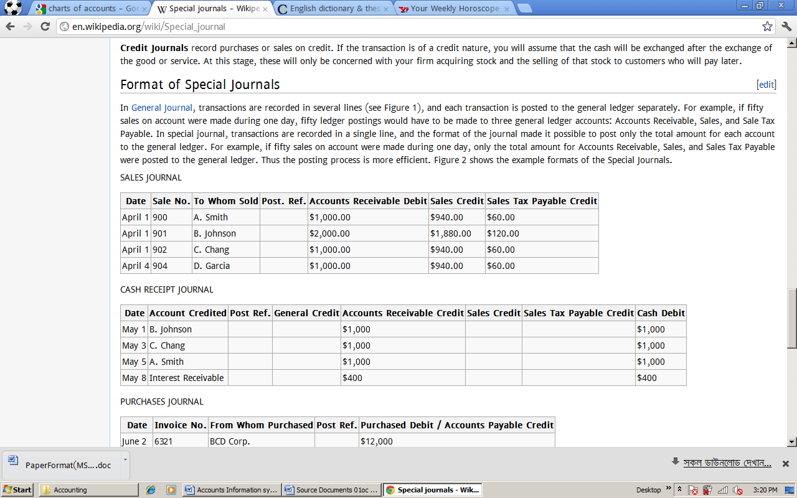

## Constraint item Purchasing power accounting

A consistent method of indexing accounts by means of a general index which reflects changes in the purchasing power of money. It therefore attempts to deal with the inflation problem in the sense in which this is popularly understood, as a decline in the value of the currency. It attempts to deal with this problem by converting *all* of the currency unit measurement in accounts into units at a common date by means of the index.

Credit terms   
[Standard](http://www.businessdictionary.com/definition/standard.html) or negotiated [terms](http://www.businessdictionary.com/definition/term.html) (offered by a [seller](http://www.businessdictionary.com/definition/seller.html) to a [buyer](http://www.businessdictionary.com/definition/buyer.html)) that [control](http://www.businessdictionary.com/definition/control.html) (1) the monthly and total [credit](http://www.businessdictionary.com/definition/credit.html) [amount](http://www.businessdictionary.com/definition/amount.html), (2) maximum time allowed for repayment, (3) [discount](http://www.businessdictionary.com/definition/discount.html) for [cash](http://www.businessdictionary.com/definition/cash.html) or early [payment](http://www.businessdictionary.com/definition/payment.html), and (4) the amount or [rate](http://www.businessdictionary.com/definition/rate.html) of late payment [penalty](http://www.businessdictionary.com/definition/penalty.html).

## Historical costs

In [accounting](http://en.wikipedia.org/wiki/Accounting), historical costs is the original monetary value of an economic item.[[1]](http://en.wikipedia.org/wiki/Historical_cost#cite_note-0) Historical cost is based on the stable measuring unit assumption. In some circumstances, [assets](http://en.wikipedia.org/wiki/Assets) and liabilities may be shown at their historical cost, as if there had been no change in value since the date of acquisition. The [balance sheet](http://en.wikipedia.org/wiki/Balance_sheet) value of the item may therefore differ from the "true" value.

Under the historical cost basis of accounting, assets and liabilities are recorded at their values when first acquired. They are not then generally restated for changes in values.

Costs recorded in the Income Statement are based on the historical cost of items sold or used, rather than their replacement costs.

For example –  
a company acquires an asset in year 1 for $100;  
the asset is still held at the end of year 1, when its market value is $120;  
the company sells the asset in year 2 for $115.

At the end year 1 the asset is recorded in the balance sheet at cost of $100. No account is taken of the increase in value from $100 to $120 in year 1. In year 2 the company records a sale of $115. The cost of sales is $100, being the historical cost of the asset. This gives rise to a profit of $15 which is wholly recognized in year 2.

## Doubtful accounts

A doubtful account is an amount that is written off by the business as a loss to the business and classified as an expense because the debt owed to the business is unable to be collected, and all reasonable efforts have been exhausted to collect the amount owed. This usually occurs when the [debtor](http://en.wikipedia.org/wiki/Debtor) has declared bankruptcy or the cost of pursuing further action in an attempt to collect the debt exceeds the debt itself.

The debt is immediately written off by crediting the [debtor](http://en.wikipedia.org/wiki/Debtor)'s account and therefore eliminating any balance remaining in that account. A bad debt represents money lost by a business which is why it is regarded as an expense.

## Trail balance

After posting all transactions from an accounting period, accountants prepare trail **balance** to verify that the total of all accounts with debit balances equals the total of all accounts with credit balances. The trial balance lists every open general ledger account by account number and provides separate debit and credit columns for entering account balances.

**Example**

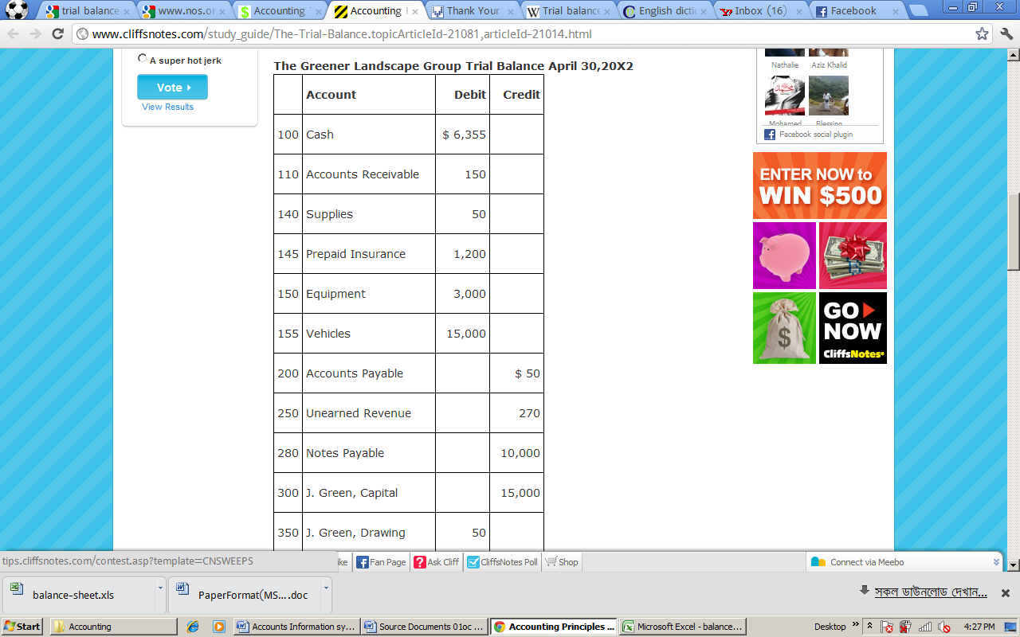

## Balance Sheet

In [financial accounting](http://en.wikipedia.org/wiki/Financial_accounting), a balance sheet or statement of financial position is a summary of the financial balances of a [sole proprietorship](http://en.wikipedia.org/wiki/Sole_proprietorship), a [business partnership](http://en.wikipedia.org/wiki/Partnership) or a [company](http://en.wikipedia.org/wiki/Company). [Assets](http://en.wikipedia.org/wiki/Asset), [liabilities](http://en.wikipedia.org/wiki/Liability_(financial_accounting)) and [ownership equity](http://en.wikipedia.org/wiki/Ownership_equity) are listed as of a specific date, such as the end of its [financial year](http://en.wikipedia.org/wiki/Financial_year). A balance sheet is often described as a "snapshot of a company's financial condition".Of the four basic [financial statements](http://en.wikipedia.org/wiki/Financial_statements), the balance sheet is the only statement which applies to a single point in time of a business' calendar year.

**Example:**

|  |  |  |  |
| --- | --- | --- | --- |
| **[ICS]** | | **Balance Sheet** | |
|  |  | **Date:** |  |
|  |  |  |  |
| **Assets** | | **2012** | **2011** |
| ***Current Assets*** | |  |  |
|  | Cash | 11,874 |  |
|  | Accounts receivable |  |  |
|  | Inventory |  |  |
|  | Prepaid expenses |  |  |
|  | Short-term investments |  |  |
| *Total current assets* | | 11,874 | - |
| ***Fixed (Long-Term) Assets*** | |  |  |
|  | Long-term investments | 1,208 |  |
|  | Property, plant, and equipment | 15,340 |  |
|  | (Less accumulated depreciation) | (2,200) |  |
|  | Intangible assets |  |  |
| *Total fixed assets* | | 14,348 | - |
| ***Other Assets*** | |  |  |
|  | Deferred income tax |  |  |
|  | Other |  |  |
| *Total Other Assets* | | - | - |
|  |  |  |  |
| **Total Assets** | | **26,222** | **-** |
|  |  |  |  |
| **Liabilities and Owner's Equity** | |  |  |
| ***Current Liabilities*** | |  |  |
|  | Accounts payable | 8,060 |  |
|  | Short-term loans |  |  |
|  | Income taxes payable | 3,145 |  |
|  | Accrued salaries and wages |  |  |
|  | Unearned revenue |  |  |
|  | Current portion of long-term debt |  |  |
| *Total current liabilities* | | 11,205 | - |
| ***Long-Term Liabilities*** | |  |  |
|  | Long-term debt | 3,450 |  |
|  | Deferred income tax |  |  |
|  | Other |  |  |
| *Total long-term liabilities* | | 3,450 | - |
| ***Owner's Equity*** | |  |  |
|  | Owner's investment | 7,178 |  |
|  | Retained earnings | 4,389 |  |
|  | Other |  |  |
| *Total owner's equity* | | 11,567 | - |
|  |  |  |  |
| **Total Liabilities and Owner's Equity** | | **26,222** | **-** |
|  |  |  | {42} |
| **Common Financial Ratios** | |  |  |
| **Debt Ratio** (Total Liabilities / Total Assets) | | 0.56 |  |
| **Current Ratio** (Current Assets / Current Liabilities) | | 1.06 |  |
| **Working Capital** (Current Assets - Current Liabilities) | | 669 | - |
| **Assets-to-Equity Ratio** (Total Assets / Owner's Equity) | | 2.27 |  |
| **Debt-to-Equity Ratio** (Total Liabilities / Owner's Equity) | | 1.27 |  |

# Some Equations of Accounting

1. Asset = Liabilities + Owner’s equity
2. Profit / Loss = Revenue - Costs -Expenses

